Department of Computer Engineering
T.E. (Computer Sem VI)Assignment -2 Artificial Intelligence (CSC604)
Student Name: ___________________________________ Roll No: ___________________
Assignment 1:

Considering the fallowing objectives :

CSC604.1: To grasp the fundamental concepts and methods involved in creating intelligent systems.
- CSC604.2: Ability to choose an appropriate problem solving method and knowledge representation technique.
- CSC604.3: Ability to analyze the strength and weaknesses of AI approaches to knowledge– intensive problem solving.
- CSC604.4: Ability to design models for reasoning with uncertainty as well as the use of unreliable information.
- CSC604.5: Ability to design and develop AI applications in real world scenarios.

A) what are the key considerations in designing an expert system that effectively utilizes knowledge representation techniques to handle uncertainty and unreliable information, while ensuring practicality in real-world applications?
B) Additionally, how do these considerations align with the strengths and weaknesses of various AI approaches to knowledge-intensive problem solving?"

- Rubrics for the First Assignments:
Indicator | Average | Good | Excellent | Marks
Organization (2) | Readable with some missing points and structured (1) | Readable with improved points coverage and structured (1) | Very well written and fully structured
Level of content(4) | All major topics are covered, the information is accurate (2) | Most major and some minor criteria are included. Information is accurate (3) | All major and minor criteria are covered and are accurate (4)
Depth and breadth of discussion and representation(4) | Minor points/information maybe missing and representation isminimal (1) | Discussion focused on some points and covers themadequately (2) | Information is presented indepth and is accurate (4)
Total
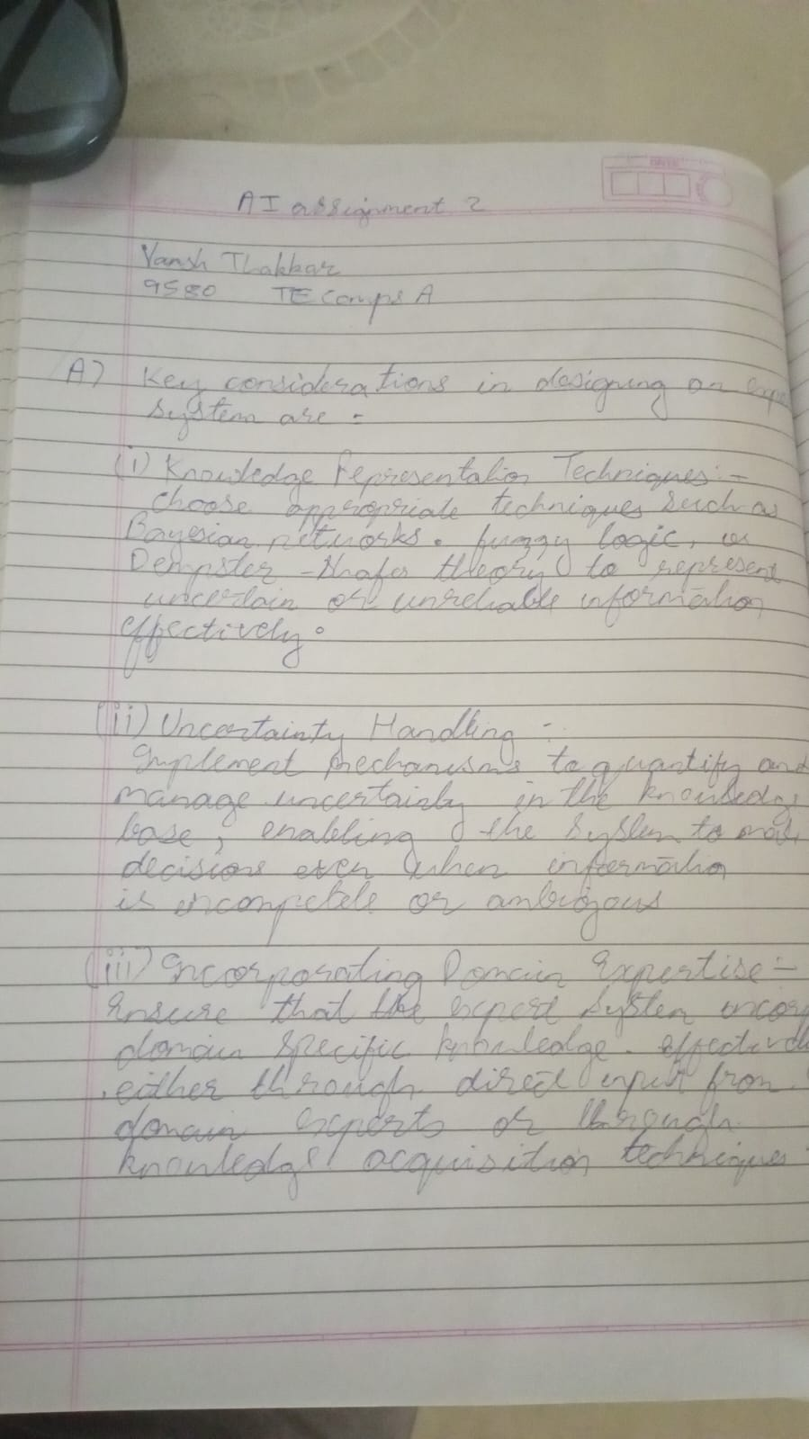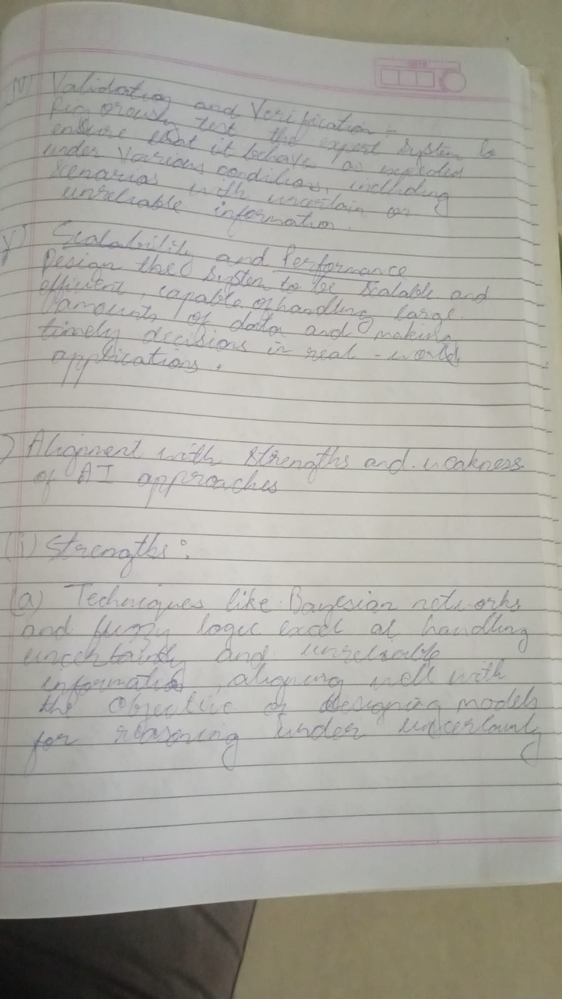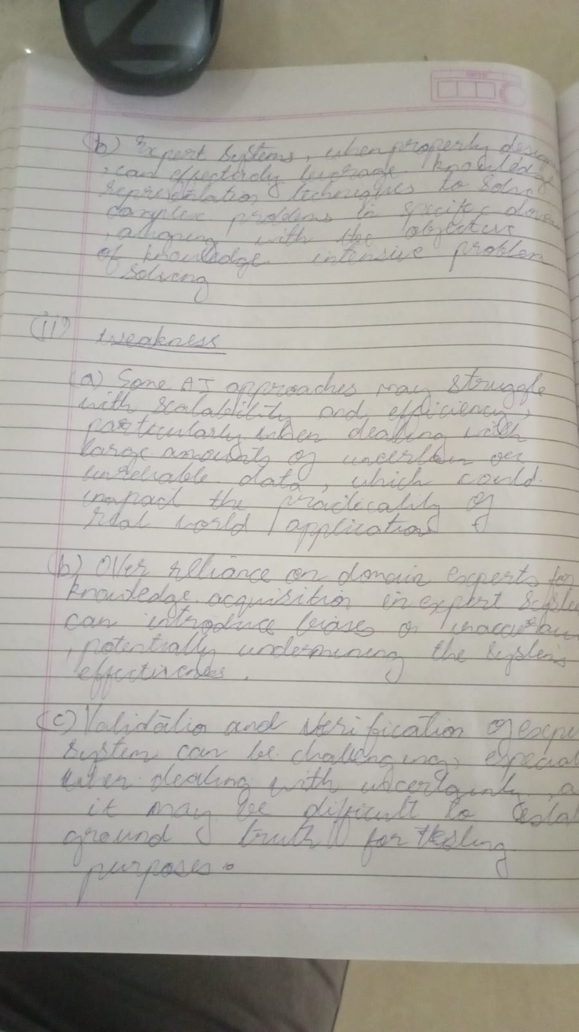

Signature of the Teacher

